Apache Airflow Capstone Exercise – 2

---- Sureshkrishna B

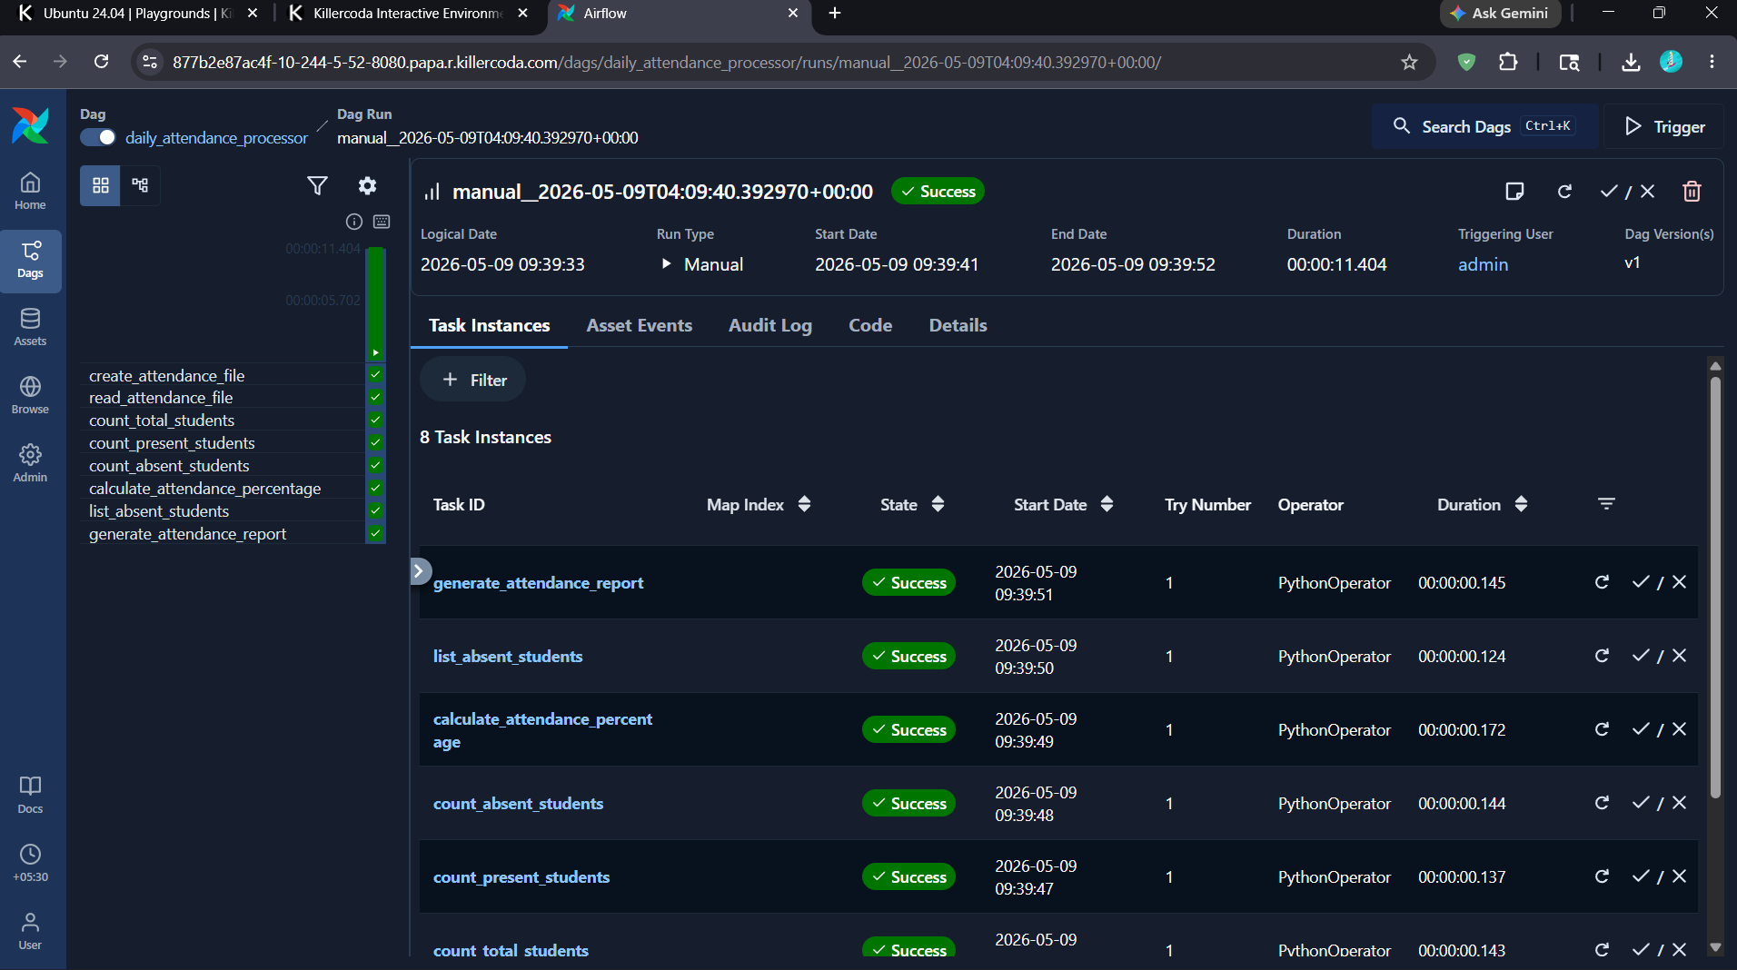

Code :
from airflow import DAG
from airflow.operators.python import PythonOperator
from datetime import datetime
def create_attendance_file():
data = """Aarav,Present
Priya,Present
Rahul,Absent
Sneha,Present
Kiran,Absent
Ananya,Present
Vikram,Present
Meera,Absent
Farhan,Present
Divya,Present"""
with open('/tmp/attendance.txt', 'w') as file:
file.write(data)
print("Attendance file created successfully")
def read_attendance_file():
with open('/tmp/attendance.txt', 'r') as file:
data = file.readlines()
print("Attendance Records:")
for line in data:
print(line.strip())
def count_total_students(ti):
with open('/tmp/attendance.txt', 'r') as file:
data = file.readlines()
total_students = len(data)
print(f"Total Students = {total_students}")
ti.xcom_push(key='total_students', value=total_students)
def count_present_students(ti):
present_count = 0
with open('/tmp/attendance.txt', 'r') as file:
data = file.readlines()
for line in data:
name, status = line.strip().split(',')
if status == "Present":
present_count += 1
print(f"Present Students = {present_count}")
ti.xcom_push(key='present_students', value=present_count)
def count_absent_students(ti):
absent_count = 0
with open('/tmp/attendance.txt', 'r') as file:
data = file.readlines()
for line in data:
name, status = line.strip().split(',')
if status == "Absent":
absent_count += 1
print(f"Absent Students = {absent_count}")
ti.xcom_push(key='absent_students', value=absent_count)
def calculate_attendance_percentage(ti):
total_students = ti.xcom_pull(
key='total_students',
task_ids='count_total_students'
)
present_students = ti.xcom_pull(
key='present_students',
task_ids='count_present_students'
)
percentage = (present_students / total_students) * 100
print(f"Attendance Percentage = {percentage}%")
ti.xcom_push(key='attendance_percentage', value=percentage)
def list_absent_students():
print("Absent Students List")
with open('/tmp/attendance.txt', 'r') as file:
data = file.readlines()
for line in data:
name, status = line.strip().split(',')
if status == "Absent":
print(name)
def generate_attendance_report(ti):
total_students = ti.xcom_pull(
key='total_students',
task_ids='count_total_students'
)
present_students = ti.xcom_pull(
key='present_students',
task_ids='count_present_students'
)
absent_students = ti.xcom_pull(
key='absent_students',
task_ids='count_absent_students'
)
percentage = ti.xcom_pull(
key='attendance_percentage',
task_ids='calculate_attendance_percentage'
)
if percentage >= 75:
status = "Good"
else:
status = "Needs Improvement"
report = f"""Daily Attendance Report
Total Students = {total_students}
Present Students = {present_students}
Absent Students = {absent_students}
Attendance Percentage = {percentage}%
Status = {status}
"""
with open('/tmp/attendance_report.txt', 'w') as file:
file.write(report)
print("Attendance report generated successfully")
default_args = {
'owner': 'airflow'
}
dag = DAG(
dag_id='daily_attendance_processor',
default_args=default_args,
start_date=datetime(2025, 1, 1),
schedule=None,
catchup=False
)
task1 = PythonOperator(
task_id='create_attendance_file',
python_callable=create_attendance_file,
dag=dag
)
task2 = PythonOperator(
task_id='read_attendance_file',
python_callable=read_attendance_file,
dag=dag
)
task3 = PythonOperator(
task_id='count_total_students',
python_callable=count_total_students,
dag=dag
)
task4 = PythonOperator(
task_id='count_present_students',
python_callable=count_present_students,
dag=dag
)
task5 = PythonOperator(
task_id='count_absent_students',
python_callable=count_absent_students,
dag=dag
)
task6 = PythonOperator(
task_id='calculate_attendance_percentage',
python_callable=calculate_attendance_percentage,
dag=dag
)
task7 = PythonOperator(
task_id='list_absent_students',
python_callable=list_absent_students,
dag=dag
)
task8 = PythonOperator(
task_id='generate_attendance_report',
python_callable=generate_attendance_report,
dag=dag
)
task1 >> task2 >> task3 >> task4 >> task5 >> task6 >> task7 >> task8

